WEB BASED STUDENT CLEARANCE SYSTEM
(A CASE STUDY OF GOMBE STATE POLYTECHNIC BAJOGA)

BY
S/N | NAMES | REGISTRATION NUMBER
 | ABDYLLAHI IDRIS ABDULLAHI | ND/CS/20/0794
 | ABDULKARIM DAUDA | ND/CS/20/0567
 | IDRIS ADAMU | ND/CS/20/0592

A PROJECT SUBMITTED TO THE DEPARTMENT OF COMPUTER SCIENCE, SCHOOL OF SCIENCE AND TECHNOLOGY, GOMBE STATE POLYTECHNIC BAJOGA IN PARTIAL FULFILLMENT OF THE REQUIREMENT FOR THE AWARD OF NATIONAL DIPLOMA IN COMPUTER

JANUARY, 2023.

DECLARATION
We hereby declare that this drudgery is the merchandise of our research work, carry out under the supervision of “Malam Haruna Ahmad Dokoro” and has not been presented and will not be presented elsewhere for the award of ND certificate. All sources have been duly accredited.
S/N | NAMES | SIGNATURE | DATE
 | ABDYLLAHI IDRIS ABDULLAHI
 | ABDULKARIM DAUDA
 | IDRIS ADAMU
 | MUSTAPHA MUHAMMAD
 | YUSHA’U MUHAMMAD

CERTIFICATION
This is to certify that the project titled “Web Based Student Clearance System” was carried out under the supervision of:-

………………………………… ………………………….………
MALAM HARUNA AHMAD DOKORO DATE
PROJECT SUPERVISOR

………………………………… ………………………….………
MR. ISMAIL ABDULKARIM ADAMU DATE
HEAD OF DEPARTMENT

………………………………… ………………………….………
NAME AND SIGNATURE DATE
EXTERNAL EXAMINER

ACKNOWLEDGMENT
Our philosophical gratitude goes to Almighty Allah the originator of the universe. This drudgery is a synergistic product of several thoughts and we sense a deep sagacity of gratitude to our parents, brothers and sisters our friends for their reinforcement and for being ever sympathetic. Our sincere thanks goes to our supervisor Malam Haruna Ahmad Dokoro for his comprehensive and methodical assistance through this work.
We raise the value of the effort and care of the Head of Computer Science Department Mr. Ismail Abdulkarim Adamu. We also confessed all the staffs of Computer Science department for their active verbal partaking and suggestions towards the evolvement of this project work.

DEDICATION
We dedicated this work to our dear parents, brothers and sister for their sustenance toward the achievement of our academic activities.

ABSTRACT
Online clearance system is an internet base research work that will help ease the queuing system in the institutions clearance process. Online clearance system will build an effective information management that is very convenient to use for schools since it is internet based and can be accessed from anywhere. It is aimed at developing a computer software system that replaces the manual method of clearance for students before school registration and that also help students to carry out their clearance without coming to the various offices for clearance. The designed software will serve as a more reliable and effective means of undertaking students clearance, remove all forms of delay and stress as well as enable you to understand the procedure involved, as well as how to do your clearance online. This project work makes use of data collection from the institutions, materials and journals from various authors and the software was developed to effectively achieve the aim of the project. In this project, the implementation of the computer based system was carried out using PHP language, Bootstrap, Html, CSS, JavaScript and the database for the software is MySQL.

TABLE OF CONTENTS
DECLARATION i
CERTIFICATION ii
ACKNOWLEDGMENT iii
DEDICATION iv
ABSTRACT v
LIST OF FIGURES ix
LIST OF TABLES x
CHAPTER ONE 1
1.0 INTRODUCTION 1
1.1 BACKGROUND OF THE STUDY 1
1.2 STATEMENT OF THE PROBLEM 2
1.3 AIM AND OBJECTIVES OF THE STUDY 2
1.3.1 AIM 2
1.3.2 OBJECTIVES 2
1.4 SCOPE OF THE STUDY 3
1.5 LIMITATION OF THE STUDY 3
1.6 RESOURCES AND TECHNOLOGY USED 3
1.6.1 HARDWARE 3
1.6.2 SOFTWARE 3
1.6.3 TECHNOLOGIES/LANGUAGES 4
1.7 DEFINATION OF TERMS 4
1.8 CHAPTERIZATION 6
CHAPTER TWO 7
LITERATURE REVIEW 7
2.1 THEORETICAL BACKGROUND 7
2.1.1 ROLE OF INFORMATION TECHNOLOGY IN THE ACADEMIC SYSTEM 7
2.1.2 DATA AND INFORMATION 8
2.1.3 TECHNOLOGY ENHANCE COMPUTER SOFTWARE BASED ONLINE CLEARANCE SYSTEM 9
2.1.4 COMPUTER-BASED ONLINE INFORMATION SYSTEM 11
2.2 REVIEW OF RELATED LITERATURE 12
CHAPTER THREE 15
ANALYSIS AND DESIGN 15
3.1 INTRODUCTION 15
3.2 PRELIMINARY INVESTIGATION 16
3.3 FEASIBILITY STUDY 16
3.3.1 ECONOMIC FEASIBILITY 16
3.3.2 TECHNICAL FEASIBILITY 16
3.3.3 OPERATIONAL FEASILITY 16
3.4 OVERVIEW OF THE EXISTING SYSTEM 17
3.5 ANALYSIS OF THE EXISTING SYSTEM 17
3.6 OVERVIEW PROPOSED SYSTEM 19
3.7 ANALYSIS OF THE PROPOSED SYSTEM 19
3.8 SYSTEM DESIGN 21
3.8.1 LOGICAL DESIGN 21
3.8.2 PHYSICAL DESIGN 26
CHAPTER FOUR 29
SYSTEM IMPLEMENTATION AND TESTING 29
4.1 INTRODUCTION 29
4.2 SYSTEM IMPLEMENTATION 29
4.3: Student Registration Modal 32
4.3 SYSTEM TESTING 36
4.3.1 UNIT TEST FOR USER’S LOGIN PAGE 36
4.3.2 INTEGRATED TESTING 37
CHAPTER FIVE 38
SUMMARY, CONCLUSION AND RECOMMENDATION 38
5.1 SUMMARY 38
5.2 CONCLUSION 39
5.3 RECOMMENDATION 39
APPENDIX A 40
APPENDIX B 47

LIST OF FIGURES
Figure 3.1: DFD for the Existing System 18
Figure 3.2: DFD for the Proposed System. 20
Figure 3.3: Architectural design of Web based student clearance system 21
Figure 3.4: Admin Use case diagram 22
Figure 3.5: Student Use Case Diagram of the Proposed System 23
Figure 3.6: Entity-Relationship Diagram (ERD) for the Web Based Student Clearance System 24
Figure 3.7: Index page 27
Figure 3.8: Student Login modal 27
Figure 3.9: Admin Dashboard 28
Figure 4.1: Home Page 30
Figure 4.2: Student Login modal 31
Figure 4.4: Student Dashboard 33
v. Admin Login Page 34
Figure 4.5: Admin Login page 34
vi. Admin Dashboard 35
Figure 4.6: Admin Dashboard 35

LIST OF TABLES
Table 1: Admin table 25
Table 2: Courses table 25
Table 3: Fees table 25
Table 4: Student table 25
Table 6: Payment Status table 26

CHAPTER ONE

1.0 INTRODUCTION
In higher institution clearance can be a process whereby regulation can be done before the fulfillment of the work. Before clearance can be fulfilled, there are certain requirements or criteria for that clearance. Student clearance system is also a process whereby a student has to be cleared in the department before registration fulfillment. In higher institution both newly admitted and returning student must be at the department.
However, the clearance for the newly admitted students differs from that of returning student. For the newly admitted students all credentials and other documents must be scrutinized in order to ascertain their authenticity and validity before allowing student to proceed with the registration processes.
With regard to the returning students, previous results must be examined in order to ensure that all previous carryovers and/or course arrears are registered first before any other fresh courses. In addition to that, clearance ensures that no student register more the maximum number of credit units he/she is supposed to register especially those students on probation.
Web based student clearance can be regarded as reliable and effective means of undertaken student clearance, remove all forms of delay and stress as well as enables you to understand the procedure involved as well as hoe to do your clearance online.

1.1 BACKGROUND OF THE STUDY
The speedy advancement in information and communication technology (ICT) has gave rise to transformation in the way activities are being executed today Chimezie(2016). To adopt the advancement in digital technology, there is need to implement the use of web based student clearance system in tertiary institutions like Gombe State Polytechnic Bajoga, there is need to automated method of keeping data, more so a greater need for online clearance system. This would help in alleviating the various problems and stress involved in the manual method of clearance Obilikwu (2015).

1.2 STATEMENT OF THE PROBLEM
The manual clearance system is associated with problems which lead to ineffectiveness of the system. The proposed automated system is expected to overcome those problems which include:
- Students registering more than the maximum number of credits unit
- Not returning of the clearance form in the appropriate time
- Students registering courses they are not supposed to register
- Proceeding with the registration process without passing through the departmental clearance
- Lack of centralized student record

1.3 AIM AND OBJECTIVES OF THE STUDY

1.3.1 AIM
The aim of this project is to design and implement a web based student clearance system

1.3.2 OBJECTIVES
The project is aimed to achieve the following objectives
- To effectively and efficiently process students clearance
- To prevent students from registering more than the maximum credit units they are supposed to register
- To ease the process of student clearance system by allowing the student to be cleared by the class advisers from their comfort zones
- To provide centralized means of keeping students record

1.4 SCOPE OF THE STUDY
The project is aimed to develop a web based student clearance system for Gombe State Polytechnic Bajoga. The system is capable clearing both fresh and returning students before the fulfillment of school registration fees. The system is expected to replace the manual method of clearing student in Gombe State Polytechnic Bajoga.

1.5 LIMITATION OF THE STUDY
The proposed system will not allow a student to make school registration, rather its only designed to make student clearance online.

1.6 RESOURCES AND TECHNOLOGY USED
The resources which include hardware and software as well as the technology needed to develop the proposed system are outline below.

1.6.1 HARDWARE
Personal computer (Laptop/desktop) is the hardware component used in developing this system using windows operating system.
The system specification are as follows :
- Processor should pentinum v and above
- A minimum of 4 Gigabyte of RAM
- Hard disk space of 250 Gigabyte and above

1.6.2 SOFTWARE
- Visual Studio Code (VS Code): visual studio code, also commonly referred ton as VS Code. Is a source code editor made by Microsoft with Electron Framework, for Windows, Linux, and Mac OS . Features include support for debugging, syntax , intelligent code completion, snippets, code refactoring, and embedded Git. Users can change the theme, keyboard, shortcuts, preferences, and install extensions that add additional functionality
- XAMP: is free and open-source cross-platform web server solution stack package developed by Apache Friends, consisting mainly of the Apache HTTP Server. Maria DB database, and interpreters for script written in the PHP and Perl programming languages. Since most actual web server deployments use the same components as XAMP, it makes transitioning from a local test server to a live server possible
- Google Chrome: is a cross-platform web browser developed by Google. It was first release in 2008 for Microsoft windows, built with free software components from Apple Webkit and Mozilla Firefox. Version were later release for Linux, Mac OS, IOS, and also for Android, where it’s the default browser.

1.6.3 TECHNOLOGIES/LANGUAGES
HTML, CSS and Bootstrap are the languages used in developing the front-end of the system, MySQL is the database used to store all the record for easy retrieval, whereas PHP is the language used to allow interaction between the server and the system while the validity of the data is achieved using JavaScript and AJAX.

1.7 DEFINATION OF TERMS
Web base : i8s any program that is accessed over a network connection using HTTP, rather than existing within a device’s memory. Web based applications often run inside a web browser .
Student :a student is a person enrolled in a school or other educational institution
Clearances : official certification of blamelessness trustworthiness or suitability to accomplish a specific objective.
Computer Network: computer network is a system that connects two or more computers together using a communication link.
World Wide Web: simply called ‘’www’’ is the important tool of the internet, it was created in the late 1980’s in Europe and was limitedly use in academics cycles.
File Transfer: Any kind of computer file that can be sent via the internet from one internet user to another. Table of account in a spreadsheet, design by a graphic artist, music and sound files etc can all be exchanged in this way
Web Browser: this is a special kind of software that process hypertext mark-up language (HTML) document. In other words, a web browser is a computer program that interprets HTML commands to collect, arranged and display the parts of a web pages.
Web Sites: A websites is a collection of many interconnected web pages organized by a specific college, organization company etc, containing web pages (goods and commodities) on the internet. Web sites is stored on web servers. There are many web sites and thousands of HTML pages on each web sites. A web is treasure of information and entertainment.
Hyperlinks: Hyperlinks are highlighted words and phrase you find on a web documents that you can click on as to jump to some other document or internet services.
Fresher: is a newly admitted student in an institution.
Returning Student: is a registered student returned for a new session.
Spill Over: Is a student returned after the year of graduation to restore his carry over courses.
Class Adviser: is a lecturer responsible for students affairs in their department.
Probation: Academic probation is the most common term colleges and universities use to indicate that a student is not making in academic progress the institution requires for graduation. Academic probation often means that a student grade/or overall GPA are not high enough to continue in school if they do not improve.
Carry Over: Over conceptually means failure in school. It signifies not being able to hit the pass mark to qualify a certification after a program. In the university settings of things, some body who couldn’t meet 40-marks pass maximum would have to rewrite the particular course again next year with his/her junior.
Course Arrears: can be refer to as courses students defers due to his some academic circumstances.
Core Course: The term ‘’core course’’ refers to the list of courses that provide a broad foundation for your education. When it comes to their admission policies, most colleges will calculate your grade point average only the grades from your core academic classes .
Elective Course: An elective course is a course that you choose to take as part of your program of study.
Step Down: is a status of academic program where by student will repeat a level of study due to his performance failure.

1.8 CHAPTERIZATION
Chapter One: Introduction
Chapter Two: Literature Review
Chapter Three: Analysis and Design
Chapter Four: Implementation
Chapter Five: Summary, Conclusion and Recommendation.

CHAPTER TWO

LITERATURE REVIEW

2.1 THEORETICAL BACKGROUND

2.1.1 ROLE OF INFORMATION TECHNOLOGY IN THE ACADEMIC SYSTEM
World net describes an information system (I.S) as systems consisting of all communication channels used within an organization and include software and hardware. It may also be define as a system that collect and process data (information) and provide it to manager of all levels that use it for decision making, planning, program implementation and control.
The information system for clearance in higher institution using computer software based online clearance system is to improve the quality and accuracy of information provided to all involved as well as assisting in compiling and reporting information, making work lesser for the management.
Information technology has been an integral part of academic system since almost four decades. According to Hewlet (1993) the world is entering an era in which technology will literally transform every aspect of business, every aspect of life and every aspect of society.
Since the arrival of internet technology, school system has taken a new shape style with a blend of convenience and satisfaction. Taylor (1980) says that computer base education includes both computer-assisted instruction programs that interact with students in a dialogue and a broader array of educational computer applications such as simulations or instructions in computer programming. Learning from a student bedroom, office or anywhere in the world has made its way into university system with the advent of internet technology. Information technology has always helped the university system to educate student in better way. To explain few examples. Student online clearance is a method where the student obtains his/her clearance letter without carrying files around. This is safe, fast and has no hassle. Filling out the documents and comparing options and writing for approval is a time consuming process. Through the internet, this process is made much easier and sometimes the approval is made within minutes. This explains an efficient way of obtaining clearance and saves time and money for students.

2.1.2 DATA AND INFORMATION
The concept of data and information are very important in understanding issues that go with development and implementation of a computer software based online clearance system. The term “data” and “information” are used interchangeably every day conversation as meaning the same thing. Too many manager and information specialist. However, these terms have distinct meaning. According to O’Leary (1996) data simply consist of raw unprocessed facts while information is a data that have been processed by the computer. Hordeski (1986) gives the following definition of data; A graphic or textual representation of facts concepts, numbers, letters, symbols or instructions suitable for communication, interpretation or processing. Data is the basic element of information that is use to described objects, ideas, conditions or situations.
Lucy (1991) defines data and information as Data is fact events, transactions and so on, which have been recorded. They are the raw materials from which information is produced. Information is data that has been produced in such a way as to be useful to the recipient. Data are fact obtained by observation, counting, measuring, weighing etc, which are often records of day-to-day transactions of the organization. For example, 20 the date, amount, and other details of an invoice or cheque, payroll details of payment, the number of a student living in a particular hostel and so on.
Enwerem (1992) argue that concept of information in an organization sense is more complex and difficult than the frequent use of this common word would suggest. Oketunji (2002) emphasized that information is data that have been processed, transmitted by the recipient, interpreted and understood by the recipient. Here it should be noted that the user, not just the sender is involved in the transformation of data into information. There is a process of though and understanding involved and if follows that a given message can have different meaning to different people. Based on this, one can conclude that data which has been analyzed, summarized or processed in some other fashion to produce a message or report which is conveniently deemed “management information” only becomes information if it is understood by the recipient. Therefore it the user who determine whether a report contains information or just processed data.

2.1.3 TECHNOLOGY ENHANCE COMPUTER SOFTWARE BASED ONLINE CLEARANCE SYSTEM
According to Jeremy v ernest, a comparison of traditional and hybrid online system in communication technology. Online system has become a central element of the discourse on higher education (Cox 2005). There seems to be an overall derive towards online 21 system given the mountain need for flexibility in scheduling and the daily emergency of communication technology and capabilities (Hill Stock, 2005).
Online system is presented as a means of conveying instruction to an extensive learning community any place at any time (Cox ,2005). Indicate that adequate designate online learning as the driving force and model for transformation in teaching, learning and formal schooling online course has the potential to provide learner individualized attention by the instructor, otherwise impossible in a large classroom environment (environmental education and training partnership 2006).
With the recent development of online system applications, many colleges and universities has began to offer online courses as an alternative to traditional face-to-face instructions. 67% of colleges and universities agreed that online education is the most logical long term strategies for their institutions (Hill stock 2005). However, there are considerable hesitation rising predominantly related quality and student respectively to online system, (Yong and Conellus 2004). Just as their advantages there are also disadvantages to the online system instruction delivery method. There is evidence through previous research that student feel isolated or disconnected when not engaged in traditional face-to-face instruction (Guhu 2001, Graham 2001), while other report indicate large success (Hoff Man 2002, Kaczynski and Kelly, 2004: mayer, 2002). There remains a lack of clarity whether online courses are as affective as traditional courses (Peirier and Feldman 2004). While there has been vast amount of research conducted on the advantages and the disadvantages of online system institution, little is known on how assessment is used in online classroom to monitor performance and progress.
Hew ,etal,(2004) describe the evaluation of current online education system at three levels; the macro level, the meso level and micro level. The macro level is an online evaluation that access an entire online program, the meso level evaluation access individual online courses, and the micro level access the learning of the online student.
Online clearance system present educational experience very different from standard face-to-face environment (Hew, Liu, Martinez, Bonk and Lee 2004). When conducting a micro level courses evaluation, interest commonly lies in learner perception of the course experience pertaining to the level of comfort, ability to communicate with class mate and the instructor, as well as comparison to traditional face-to-face lecture. Many times the only means of evaluating learner perception is in the form of a questionnaire or survey. Although perception of online system can be extremely useful information, it is usually not sufficient to conclude the evaluation without expanding to learners understanding.

2.1.4 COMPUTER-BASED ONLINE INFORMATION SYSTEM
An information specialist Lucey (1991) define computer based management information system as: the combination of human and computer based resource that result in the collection, storage, retrieval, communication and use of data for the purpose of efficient management of operations and for business planning.
Computer based information system is a feature of all large organization nowadays. The literature identifies four kinds of computer based information: Transaction processing system (TPS), management information system (MIS), decision support system (DSS) and executive support system (ESS). Some system record routine activities: Employees hired, material purchased or produced and the like. Such recorded events are called transactions. Other system uses this recorded event to help managerial planning and control. The systems form a pyramid each primarily supporting one another level of management.
a. Transaction processing system (TPS): these system record day-to-day transactions such as customer order, bills, inventory levels and production output. The TPS helps supervisors by generating data base that act as foundation for other information system.
b. Management information system (MIS). These summarize the detailed data of the transaction processing system standard report for middle level managers. Such report might include production schedules and budget summarizes.
c. Decision support system (DSS); The DSS provide the flexible tools for analyzes. The DSS help middle level managers and other in the organization analyze a wide range of problem, such as effect of event and trend outside the organization. Like the MIS, the DSS draws on the detailed data of transaction processing system.
d. Executive support system (ESS): The ESS is easy-to-use systems that present information in a very highly summarized form. It helps top level management to oversee the company operation and develop strategic plans. The ESS combines internal data from TPS and MIS with external data.

2.2 REVIEW OF RELATED LITERATURE
Clearance is a certificate giving permission for something to be done. In higher institution of learning, students that have satisfied the academic requirements for registration must undergo a clearance process before the school registration from the institution. The above fact prompted the development of a web-based database-driven students’ clearance system by Agbo-Ajala and Makinde (2015). The system was developed using PHP and MySQL, and is aimed at eliminating the delays associated with the manual process of final clearance. In similar manner, Umezinwa, Uwakwe and Abode (2015) developed online clearance system for clearance of Imo State University using PHP, JAVASCRIPT, CSS, APACHE and MySQL for the database. The above system was able to process data with great speed and also replaces the error-prone manual clearance system.
Zuhaib (2013) supervised a project on the development of online clearance system using ASP.Net to create interfaces of the system. The system which was implemented at Quest University, Nawabshah contain database that can store all the required information of students for clearance certificate via web pages. Awuzie (2013) summarizes the advantages of online clearance system to include the following:
i. It save a lot of time.
ii. It is very convenient to use anywhere at any time e.g., office, bedroom or anywhere in the world.
iii. Information processing is very fast and delay can be avoided.
iv. It is inexpensive to students and school management.
v. It also help the school in reducing cost such as labour and stationery.

CHAPTER THREE

ANALYSIS AND DESIGN

3.1 INTRODUCTION

There are many occasions during these stages when the database developer must detain the necessary facts to construct the required database system. The necessary facts include the terminology used inside the enterprise, problems encountered using the current system, chances sought from the new system, necessary constraints on the data and users of the new system, and a prioritized set of requirements for the new system. Below are the fact finding techniques used to developed the proposed system.
1. Interviewing is the most frequently used, and usually the most useful, fact-finding procedure used. We used interview to collect information from person face-to-face. There can be several objectives for using interviewing, such as finding out facts, verifying those facts, clarifying these released facts, generating enthusiasm, getting the end-user involved, identifying requirements, and gathering ideas and opinions. However, using the interviewing practice must require proper communication skills for dealing effectively with people who have different values, priorities, opinions, motivations, and personalities.
2. Research: Also useful fact-finding technique is to research the application or the problem that you are dealing with and want to put within a database. However, Computer trade journals, reference books, and the Internet are used in developing the proposed system, because research served as a good source of information that is available and provide vast quantity of information on how others have solved similar problems/issues plus whether or not any software packages exist to resolve or even partially solve your current problem.

3.2 PRELIMINARY INVESTIGATION
The techniques used in gathering data to developed the proposed system was interview. The interview was carried out with the various departmental class advisers in order to find answers to the following questions.
- How the manual system works,.
- What are the challenges faced with the manual system.
From the data gathered, the analysis shows that the manual system encompasses a lot of bugs which include queuing during clearance process, lack of data security, time consuming as well high cost.

3.3 FEASIBILITY STUDY
Feasibility studies was conducted after facts about the existing system was gathered. The proposed system was evaluated based on the three feasibilities: economic feasibility, technical feasibility and operational feasibility. The evaluation indicates that the proposed project is feasible.

3.3.1 ECONOMIC FEASIBILITY
The newly developed system is feasible in term of economic feasibility because of the project does not require much in terms of funds which is not beyond the ability of the developers.

3.3.2 TECHNICAL FEASIBILITY
The technical aspects required to develop the system are feasible, this include markup language i.e. HTML (Hypertext Markup Language), Cascading Style Sheet (CSS), Hypertext Preprocessor (PHP), JavaScript, Bootstrap and MySQL as the system Database. These are the technologies we used in developing this system.

3.3.3 OPERATIONAL FEASILITY
The system was developed according to the available requirements as well as the skilled manpower of the organization. There is also system documentation where the skill of the users of the system can be enhanced. As such, the proposed system is considered operationally feasible.

3.4 OVERVIEW OF THE EXISTING SYSTEM
The existing system was completely manual where by, a student (fresh, returning, and spill over) must come to the department and present himself to the departmental class adviser. The class adviser verify all necessary documents in order to ascertain the eligibility or otherwise of the student. Once the student is found to be eligible for registration, he/she will be cleared to proceed with remaining registration processes.

3.5 ANALYSIS OF THE EXISTING SYSTEM
The data gathered for the existing system was using descriptive analysis tool where the result of the analysis shows that the system lack accuracy. The clearance took long time and result in queuing during the completion of the process. Moreover, records are not securely saved because they are in ordinary files.

Returning
Matric
Number
Results
Verify result

Pay departmental dues
Fresh
Admission letter,
Credentials, and dues

Course registration
List of cleared students

Clearance slip

Figure 3.1: DFD for the Existing System

3.6 OVERVIEW PROPOSED SYSTEM
The proposed system is to clear student online. The system contained the following modules, users of the system and their functionalities.
- Login Module authenticate user by accepting their login credentials and access is granted if the authenticated is successful otherwise access is denied.
- Course module is the module that allows admin to register courses to be taken by student for both first and second semesters.
- Payment module is the module that manages the payment of departmental dues.
- Request module is the module that allow the approval and disapproval of a request in the system.
However, the users of the system include admin who is the in charge of all the activities carried out in the system; a student who register and request for course registration approval in order to pursue the course registration.

3.7 ANALYSIS OF THE PROPOSED SYSTEM
The web based clearance system was developed using the Waterfall Model of a Software Development Life Cycle (SDLC). Also, the analysis tool used in conducting the research to meet all the stated significance is descriptive analysis.

Database
Login credentials
User authentication

Verify previous result
Matriculation
number

Pay departmental dues
Admission letters
Credentials

Course registration

Clearance slip

Figure 3.2: DFD for the Proposed System.

3.8 SYSTEM DESIGN
The Web-based student clearance system was designed based on the necessities and specifications. The logical as well as the physical design of the proposed system is accessible here. Waterfall model was adopted on the SDLC for the proposed system because the system requirements are well defined and could be easily observed during development.

3.8.1 LOGICAL DESIGN
i. System Architecture
The system architecture shows the behavioral design of the system. The interconnection between the admin, student and web server in the system database, below is the system architecture.

Administrator
Browser

Browser Interface
Student
Software
Server (Xamp)

MySQL DB

Figure 3.3: Architectural design of Web based student clearance system
ii. Use case diagram
The Use Case Diagrams (informal graphical representation of requirements) show the user requirements and a more detailed system requirements (specific functions to be carried out by the system) for the web based student clearance system are also presented.
A) The Admin
1. Log in to the system.
2. Manage payment
3. Manage students
4. Manage Department
5. Manage courses.
Admin
Login/logout
Manage
Courses
Manage Departments
Manage Payments
Manage student
Clear student

Figure 3.4: Admin Use case diagram

B) The Student
The Student’s Use case diagram indicates that student shall be able to:
1. Log in to the system
2. Make payment and
3. Print Slip
Make Payment
Print slip
Login/logout

Student

Figure 3.5: Student Use Case Diagram of the Proposed System
iii. Entity Relationship Diagram
This diagram represent the model of student clearance system entity. The entity-relationship of student web based clearance system shows all the visual instrument of database tables and the relationship between the admin, student and payment with their respective entities. The diagram below represents the entity diagram in the database of the proposed system.
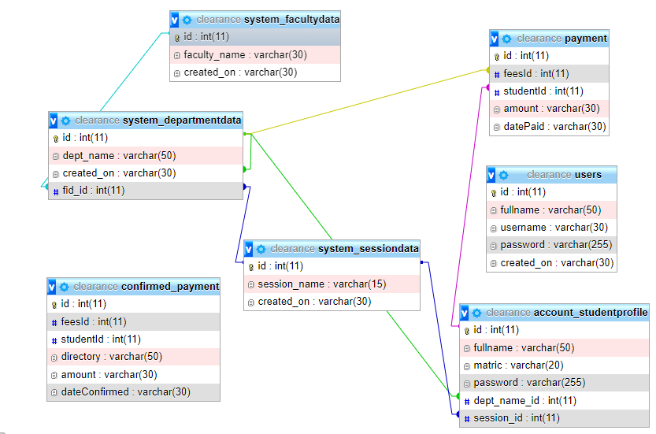

Figure 3.6: Entity-Relationship Diagram (ERD) for the Web Based Student Clearance System
- Database Tables
The information on the database of the website which is in formatted tables, making it a relational database, it has to be regularly updated and edited. Since it has to reflect current changes to reflect the current events as they unfold. Among the tables to be regarded as master files in this research work is:

i. Users Table
This table contained the list of the users including the admin, the basic column in the table are: id column, username, password, email. The password field is encrypted to banned unauthorized users get access to the system.

Table 1: Admin table

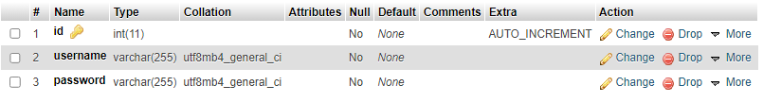

Table 2: Courses table

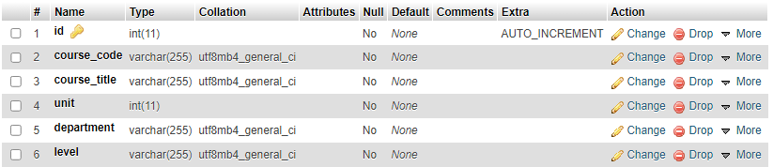

Table 3: Fees table

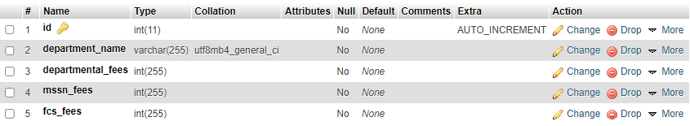

Table 4: Student table

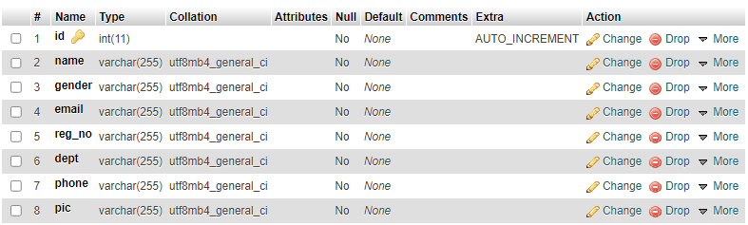

Table 6: Payment Status table

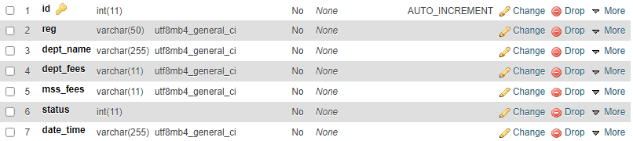

3.8.2 PHYSICAL DESIGN
- Interface Design
User interface (UI) is the space where interactions between humans and machines occur. The goal of this interaction is to allow effective procedure and control of the machine from the human end, whilst the machine simultaneously feeds back information that aids the operators' decision-making process. The interface is heavily built using HTML, CSS, Bootstrap and JavaScript.
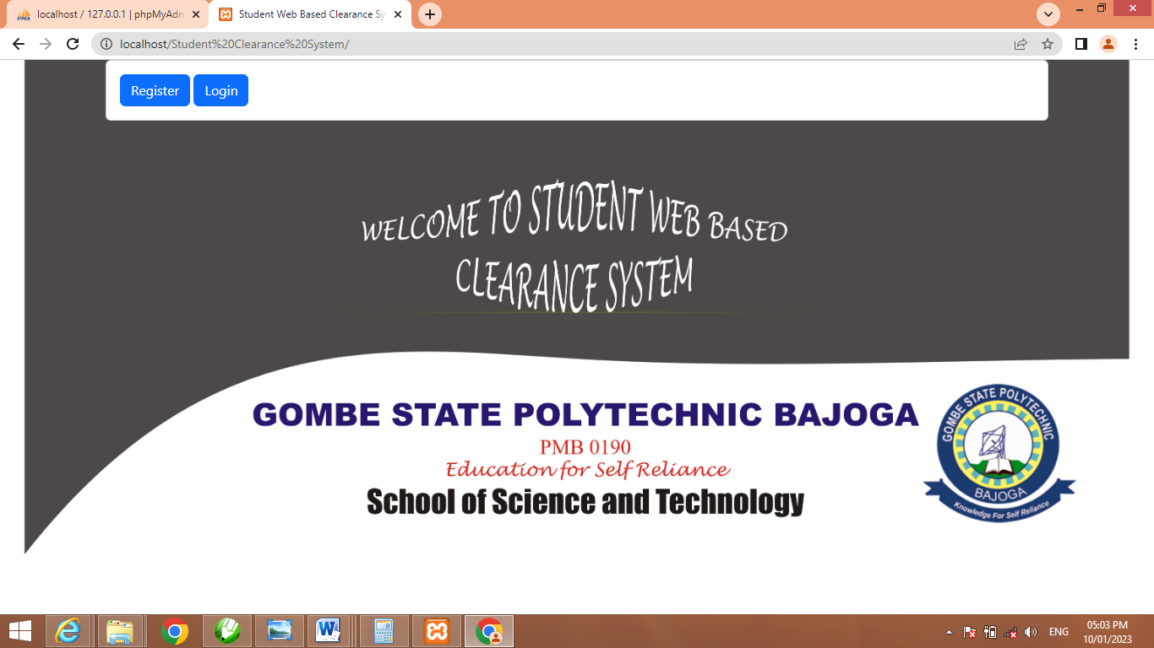

Figure 3.7: Index page
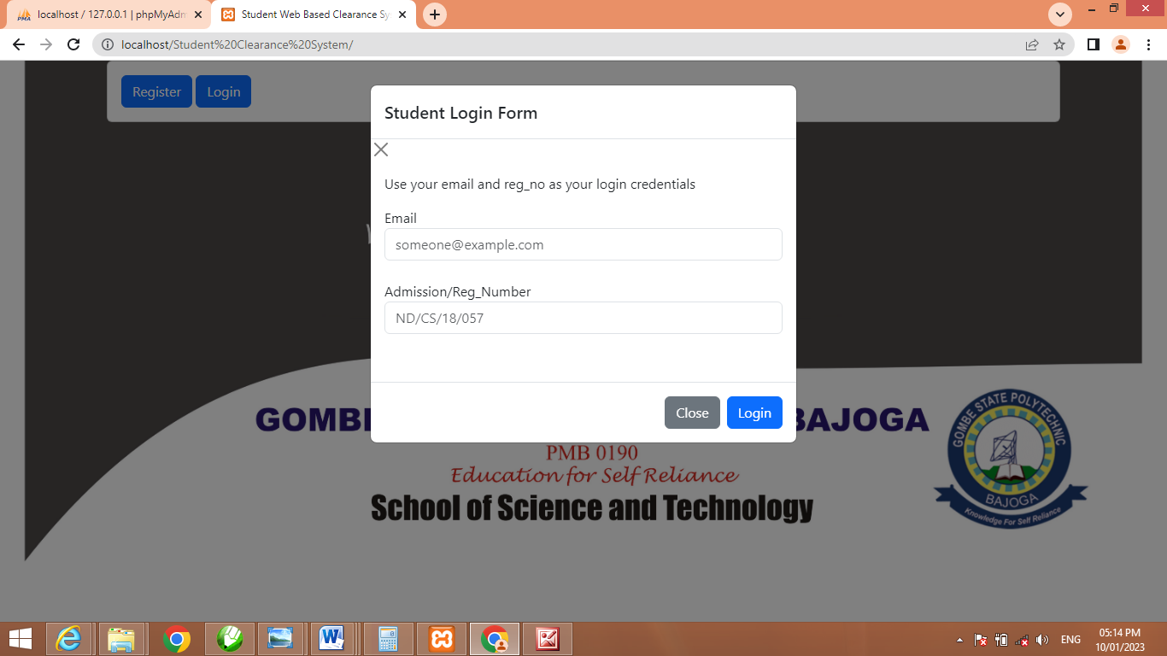

Figure 3.8: Student Login modal

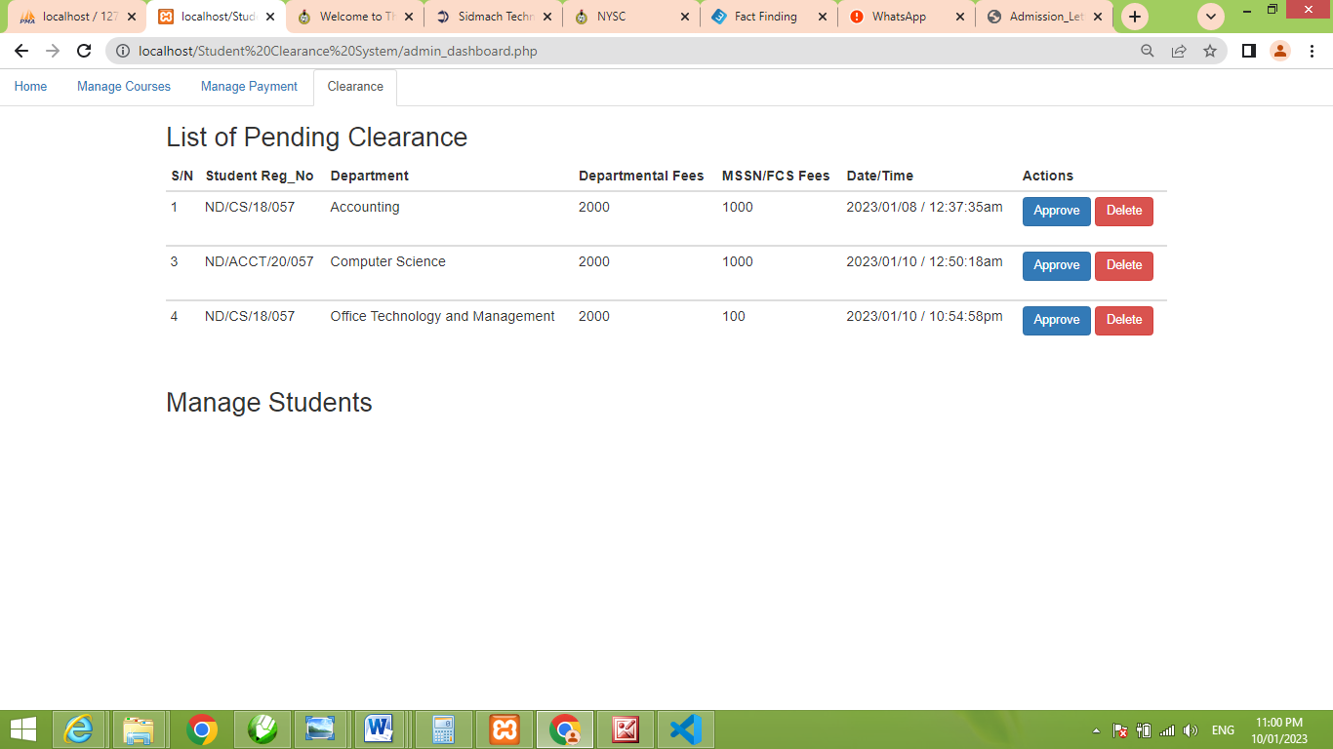

Figure 3.9: Admin Dashboard

CHAPTER FOUR

SYSTEM IMPLEMENTATION AND TESTING

4.1 INTRODUCTION
Systems implementation is the process of putting the system design into action. Testing is conducted in order to evaluate the system’s compliance with its specified requirement.
HTML, CSS and Bootstrap are the languages used in developing the front-end of the system, MySQL is the database used to store all the records for easy retrieval, however PHP is the language used to consent interaction between the server and the system while the validity of the system were achieved using JavaScript and AJAX. System Testing involves the technique of executing a program using a test data with the diligence of detection and correcting imprecisions in the program. Unit testing is used in order to test this system. Unit testing is a software testing method by which individual units of source code—sets of one or more computer program modules together with associated control data, usage procedures, and operating procedures—are tested to determine whether they are fit for use. Wikipedia, 2022.
This section presents the implementation of the different modules of the CBTS and the testing of these modules to ensure that they function in accordance with the CBTS requirements.
The system front-end was heavily build using HTML and CSS while the back-end was build using PHP to interact the system with the data base. JavaScript was used to handle the prompting event in the system. Below are some pictures showing different interface in the system:

4.2 SYSTEM IMPLEMENTATION
This section grants the implementation of the different modules of the Student Web Clearance System these modules to ensure that they function in accordance with the System requirement requirements.
The system front-end was heavily build using HTML and CSS and Bootstrap while the back-end was build using PHP to interact the system with the data base. JavaScript was used to handle the prompting event in the system. Below are some pictures showing different interface in the system:
i. Home Page
This is the welcoming page in the system where the name of the system as well as the school appeared. A student can register or otherwise login to access his dashboard.

Figure 4.1: Home Page

ii. Student Login Modal
This is a in the system where an student can login using his login credentials to access his dashboard.

Figure 4.2: Student Login modal

iii. Student Registration modal
This is a modal in the system where a student can register in to the system in order to login and access his dashboard.
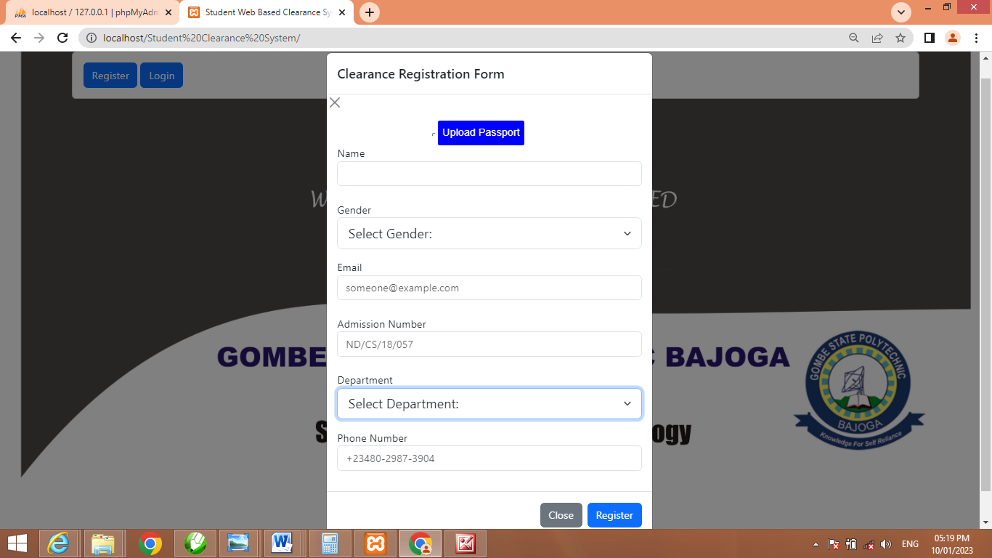

4.3: Student Registration Modal

iv. Student Dashboard
This is where a student can only have access to in the system. He can make payment; select his department and request for admin approval. Often when admin approved his request he can move toward course registration respectively.

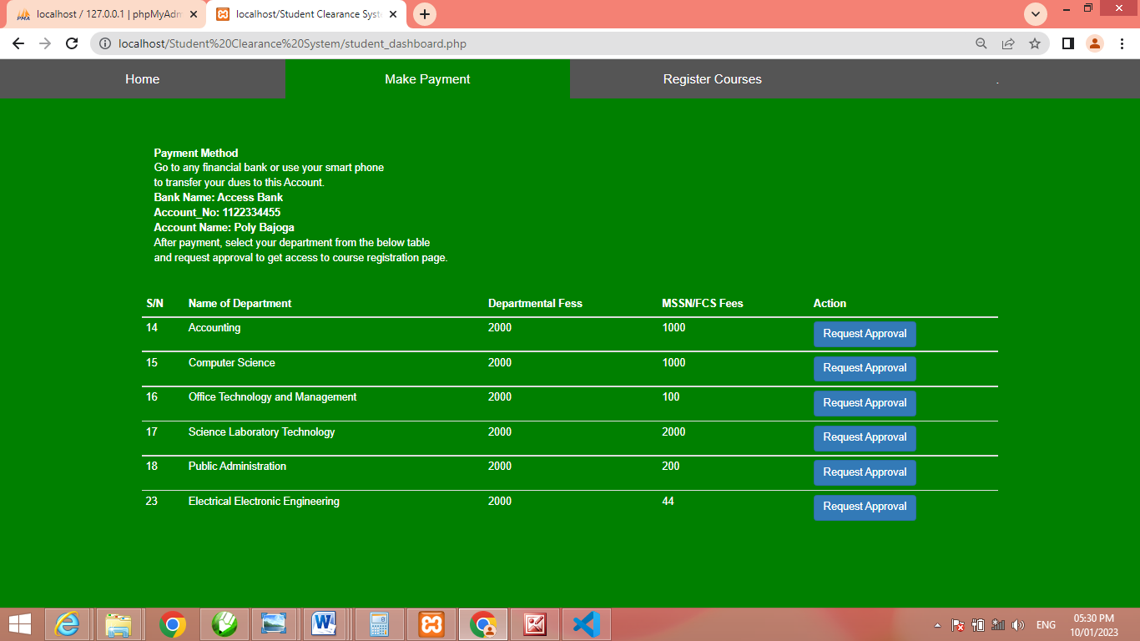

Figure 4.4: Student Dashboard

v. Admin Login Page

This is the page where the admin can input his credentials and have direct access to his dashboard. Often when admin input wrong credentials the system will not grant him access to his dashboard, rather, an error message will be displayed alerting danger on wrong credentials.
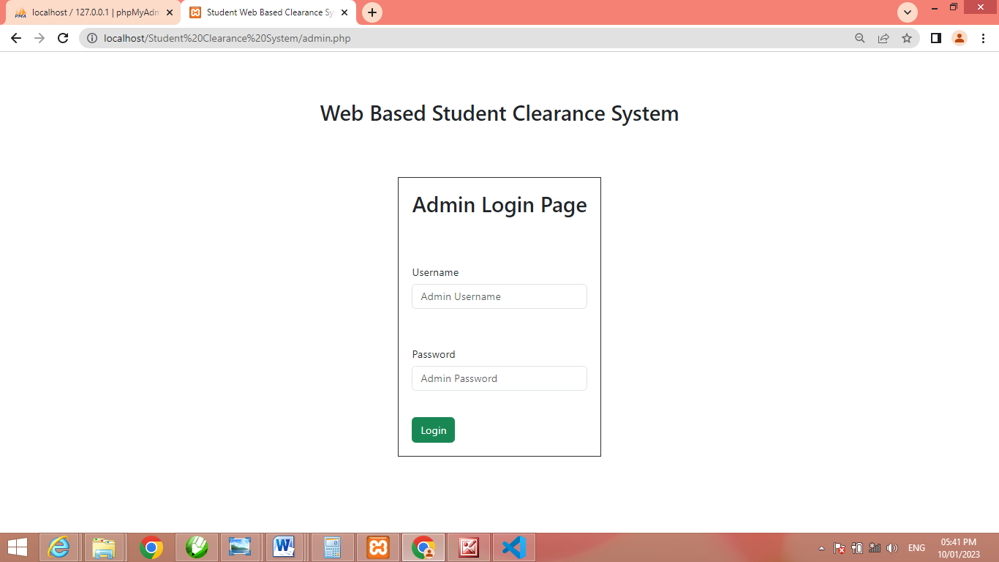

Figure 4.5: Admin Login page

vi. Admin Dashboard
The admin dashboard is page where admin can access and manage the activities of the system. In this page, the admin can manage courses by adding, updating as well as deleting a course. So also, he can manage payment by adding departmental as well as other dues for student. Nevertheless he can create, update and delete a student in the system finally worthy of being said is that he can delete or approve a requested message from a user (student in the system) which serve as the clearance.
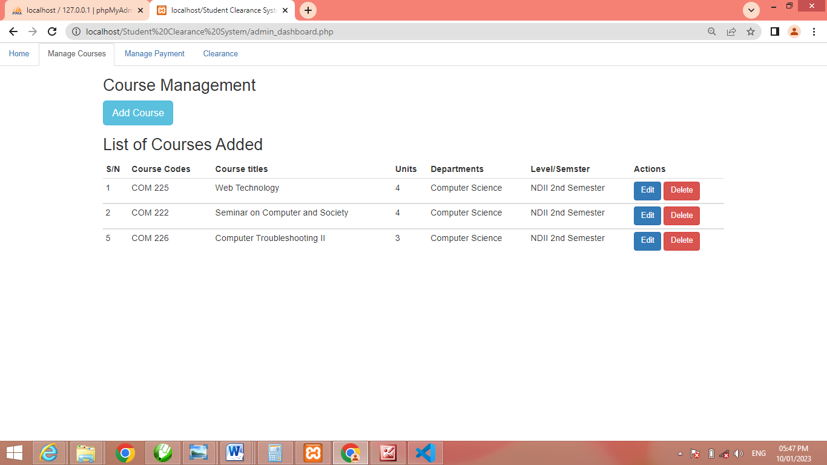

Figure 4.6: Admin Dashboard

4.3 SYSTEM TESTING
Unit and Integration Testing
Different modules (units), integrated system, including the system database were tested to ensure that the system is completely free from bugs. While unit testing embroils testing the individual mechanisms that make up the system, integration testing is primarily apprehensive with finding faults in the entire system. The database which is made up of a group of logically related tables was also tested to ensure that the set of rules and constraints guiding the type of data stored in the tables are not violated.

4.3.1 UNIT TEST FOR USER’S LOGIN PAGE
TEST | STEPS | EXPECTED RESULT | TEST RESULT
Authorized Admin Login | input username, password  click the login button | Show login successful | Display admin dashboard
Authorized Student login | input email, registration number  click the login button | Show login successful | Display student dashboard
Display data | Automatically query  the data from the  server | Show data on the dashboard | Data shown on  the dashboard
Un-authorized user | input username, password  click the login button | Show incorrect login | Reload login page
Non-active user | input email, registration number  click the login button | Show incorrect login | Reload login page

4.3.2 INTEGRATED TESTING
Integration testing occasionally called integration and testing, abbreviated, is the segment in software testing in which individual software modules are combined and tested as a group. Integration testing is conducted to evaluate the compliance of a system or component with specified functional requirements. The followings are the basic module of the system:
1. Login Module
2. Dashboard Module
3. Course Module
4. Student Module
Integrated Testing table
Test Case Id | Test Case Objectives | Test Case Description | Expected Result
1. | Check the link between login page and dashboard module | After inputting credentials click login button | Get Directed to dashboard
2 | Check the link between student approval request module | Approve student payment status | Set payment id to access course registration page
3. | Check payment status before proceeding to course registration | Get approval from admin to access course registration page | Get access to course registration

CHAPTER FIVE

SUMMARY, CONCLUSION AND RECOMMENDATION

5.1 SUMMARY
The use of web based student clearance system forms the basis of the school management decision. It aims at providing the management with adequate, effective, well documented up-to-date and formatted output. To help as a tool in planning and decision making/based on the student clearance form.
The lack of learner outcome variation of the online system signals the establishment of concurrency between the two measures even though they are measures of same construct. This investigation supports the use the online system delivery structure to broaden the instruction audience in technology education program.
The use of online clearance system in technology education at the institutions remain at the minimal level as suggested by the 80% of the online student participants, predominantly technology education measures who report that they have not done online clearance previously. Also 75%of online student participant report that they have not used web based student clearance system previously. Having come to completion of this project work a lot of achievement was made and they include;
1. The replacement of error prone manual system with new automated web based student clearance system.
2. Data can now be processed with great speed and efficiency.
3. The application has the ability to update record in various files automatically there relieving the institutions staff the stress from working from file to file.
4. The security of data is ensured, the use of database server was implemented.

5.2 CONCLUSION
Research and development are continuous processes; this is same in computer and software development. However the effectiveness and efficiency of this new system provide room for further improvement. As early mentioned some of the objectives of this project were not actualized due to some limitation. So this objectives could be improved upon, the outline clearance system developed will offer greater opportunity in school management.

5.3 RECOMMENDATION
The research work carried out is limited to online clearance only. It would be better if a full portal is developed for effective and wholesome of information management technology in our institution. When this is done the following modules are recommended to include in the portal.
1. Developing an online students admission system to enable full tracking of student records.
2. Automation of student academic record to enable the management to have access to student academic performance.
3. Maintaining a central database for accessing information relating to student.

REFERENCES

Anigbogu. (2017). Effect of Manual Method of Clearance. National Journal on Web Based Application, 4-10.
Chimezie. (2016). The Speed Advancement In Information and Communication Technology (ICT). International Journal on ICT, 33-34.
Conellus, Y. a., & Guhu. (2004,2001). impact and effect of online system instruction delivery method. journal on informatics and research, 42-50; 65-70.
Conellus, Y. a., Ghuhu, Graham, & Mayer, K. &. (2004). Advantyage and Disadvantages of Online System Instruction Delivery. International Conference on online System, (pp. 50-62; 168-169). Barcelona, Spain.
Cox. (2005). Online sytem as a central element. internal conference on online system, 44-60.
Enwerem. (1992). information management. journal of information technology, 35-40.
Enwerem, Oketunji, Enernest, J. V., & Stock, H. (1992, 2005.). Concept of Information and Technology . Conference in Information Technology, (pp. 101-104). Mexico.
Feldma, P. a., liu, H., & Mauritine, B. a. (2004). online System Presentation.
Hewlet. (1993). Global Change of Technology. International Conference on Global Technology, 52-54.
Hodesk. (1986). Data and Information. Newyork: United Nations.
Lucy. (1991). Facts on Data and Information in an organization. National Journal , 102-103.
Lucy, Ajala, A., & Makinde. (1991). Disadvanates of Manual System in an Organization. Internal Journal , 89-92.
Oblikwu. (2015). Impact of Web Base Application. National Journal on Web Based Application, 13-15.
O'leary. (1996). Data and Information communication. national of Information Technolgy, 23-32.
Taylor. (1998). The impact of E-learning. journal of informatics and research , 7-14.
Umezinwa, & Abode, U. a. (2015). Development of Online Clearance System for Imo State University. State Journal , 46-50.
Zuhaib, Nawabshah, & Awuziew. (2019, September 01). Data that stores all students information for clearance. pp. 303-308.

APPENDIX A
<?php include ('server.php');
//include 'add_fees.php';
?>

<html>
<head>
<meta charset="utf-8">
<meta name="viewport" content="width=device-width, initial-scale=1">
<link rel="stylesheet" href="https://maxcdn.bootstrapcdn.com/bootstrap/3.4.1/css/bootstrap.min.css">

</head>
<body>
<div class="container">
<a href="logout_admin.php"><h3> Logout </h3></a><br></div>
<!-- Nav tabs -->
<ul class="nav nav-tabs" id="myTab" role="tablist">
<li class="nav-item">
<a class="nav-link active" id="home-tab" data-toggle="tab" href="#home" role="tab" aria-controls="home" aria-selected="true">Home</a>
</li>
<li class="nav-item">
<a class="nav-link" id="profile-tab" data-toggle="tab" href="#profile" role="tab" aria-controls="profile" aria-selected="false">Manage Courses</a>
</li>
<li class="nav-item">
<a class="nav-link" id="messages-tab" data-toggle="tab" href="#messages" role="tab" aria-controls="messages" aria-selected="false">Manage Payment</a>
</li>
<li class="nav-item">
<a class="nav-link" id="settings-tab" data-toggle="tab" href="#settings" role="tab" aria-controls="settings" aria-selected="false">Clearance</a>
</li>
</ul>

<!-- Home -->
<div class="tab-content">
<div class="tab-pane active" id="home" role="tabpanel" aria-labelledby="home-tab"><div class="container">
<h2>List of Successful Cleared Students</h2>
<h4>Use your Registration Number and Approval Code to Access Course Registration! </h4>

<?php
$connection= mysqli_connect("localhost", "root", "");
$db= mysqli_select_db($connection, 'studentclearance');

APPENDIX B

HOME PAGE

STUDENT LOGIN FORM

STUDENT CLEARANCE FORM

